#Spring Boot Application

<https://www.youtube.com/watch?v=UfOxcrxhC0s>

1. Introduction the Spring boot
2. Installation of Spring Boot
3. MVC Architecture
4. Dependency Injection
5. Web Application Using Spring -Boot
6. Submission form in Spring Boot
7. What is REST Api
8. Spring Data REST
9. Spring Boot Security
10. Spring Boot Interview Question
11. What is Spring boot ?
12. Features of Spring Boot:
    1. Spring CLI
    2. Spring Initializer
    3. Spring Actuator
    4. Stater Dependency
    5. Auto -Configuration
    6. Logging & security

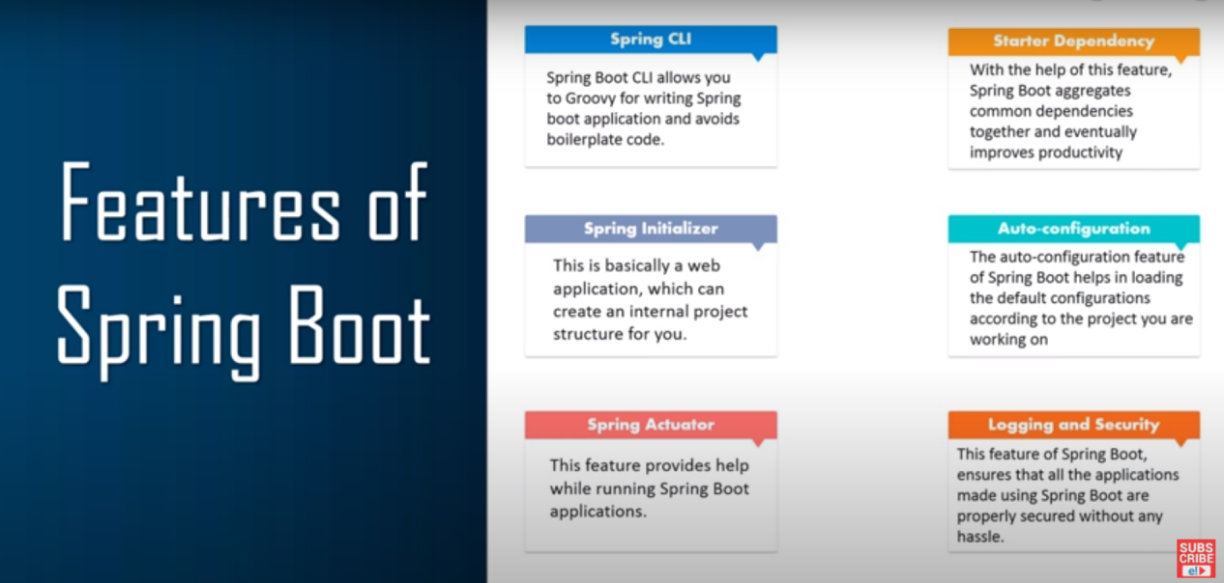

1. Why Do we need Spring Boot ?

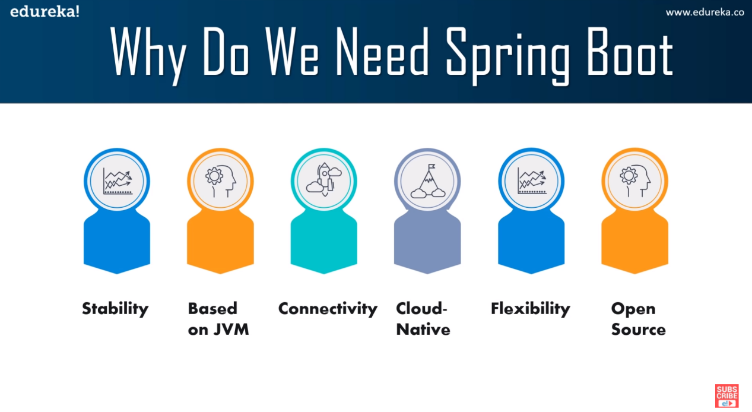

1. Difference Between Spring and Spring Boot .

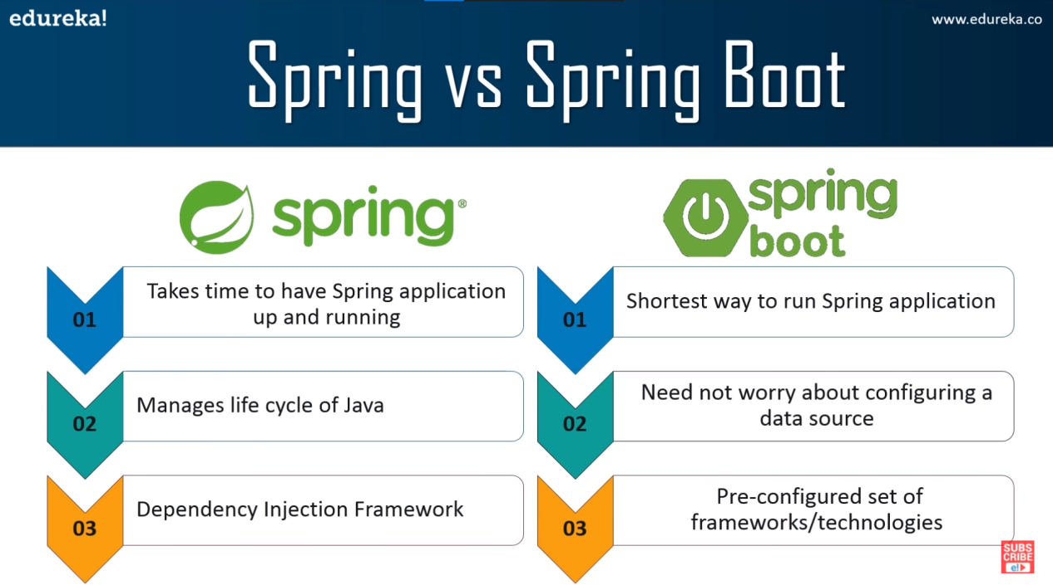

1. Installation of Spring boot :

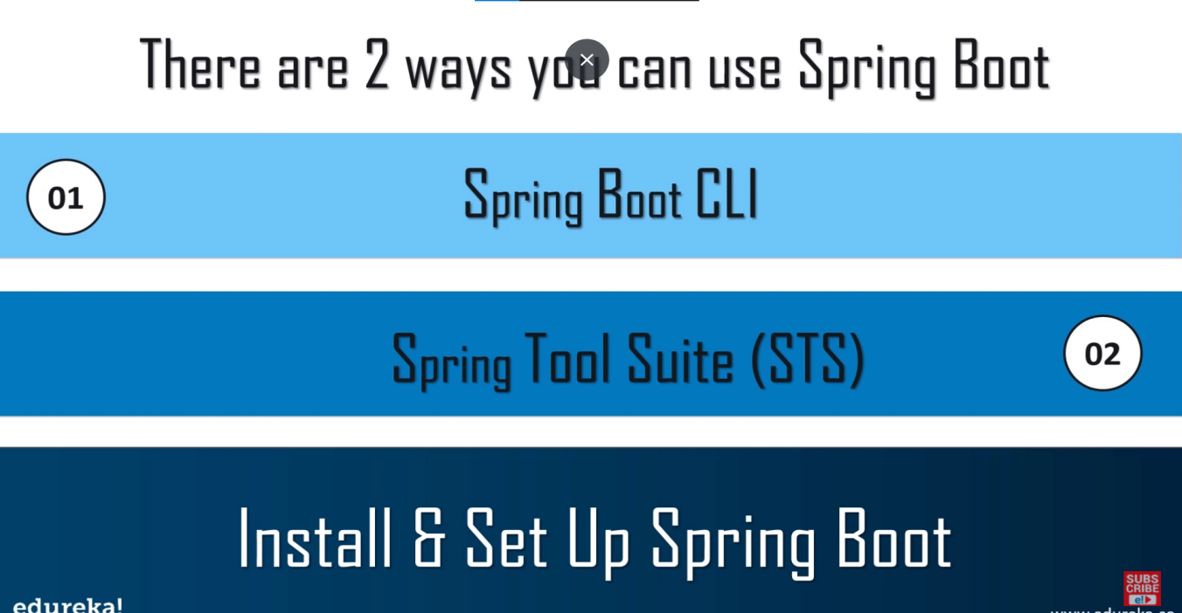

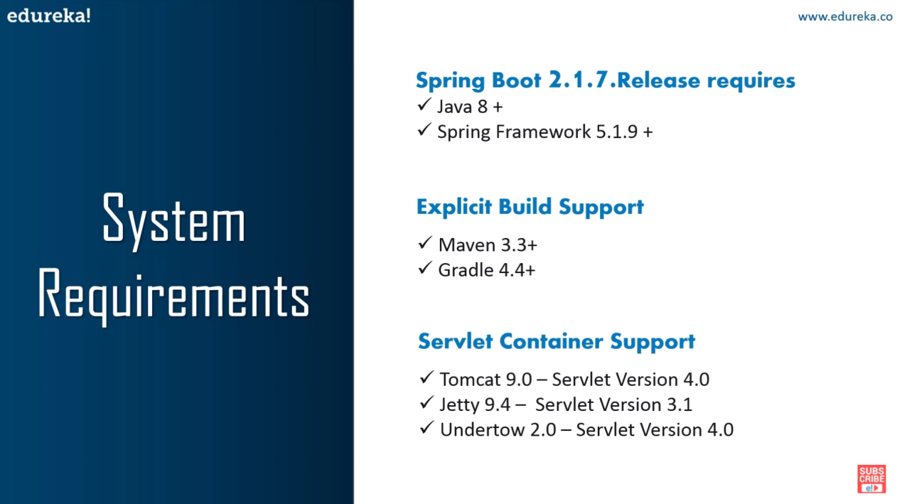

16 . MVC

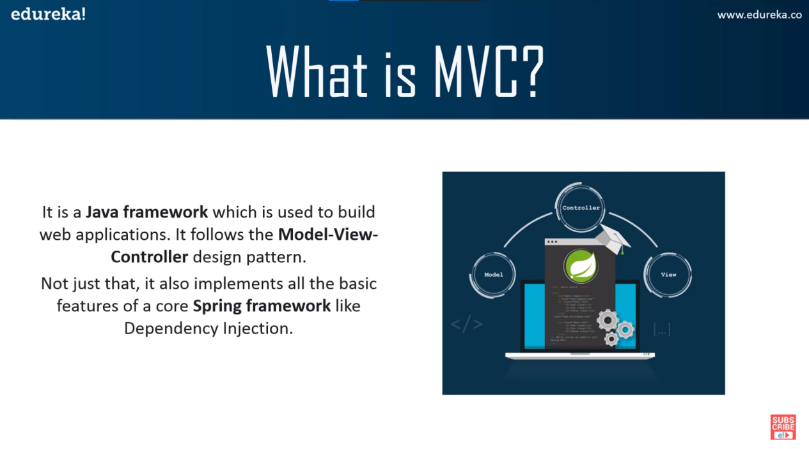

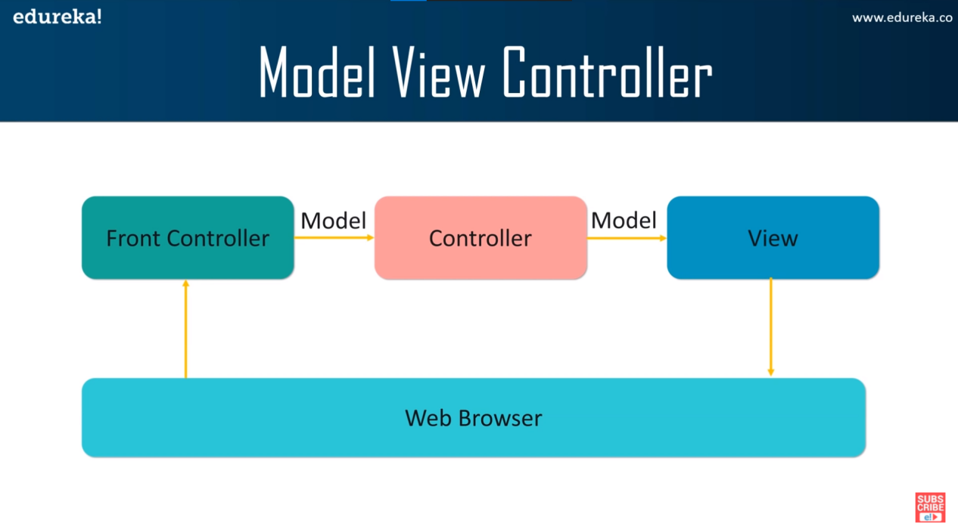

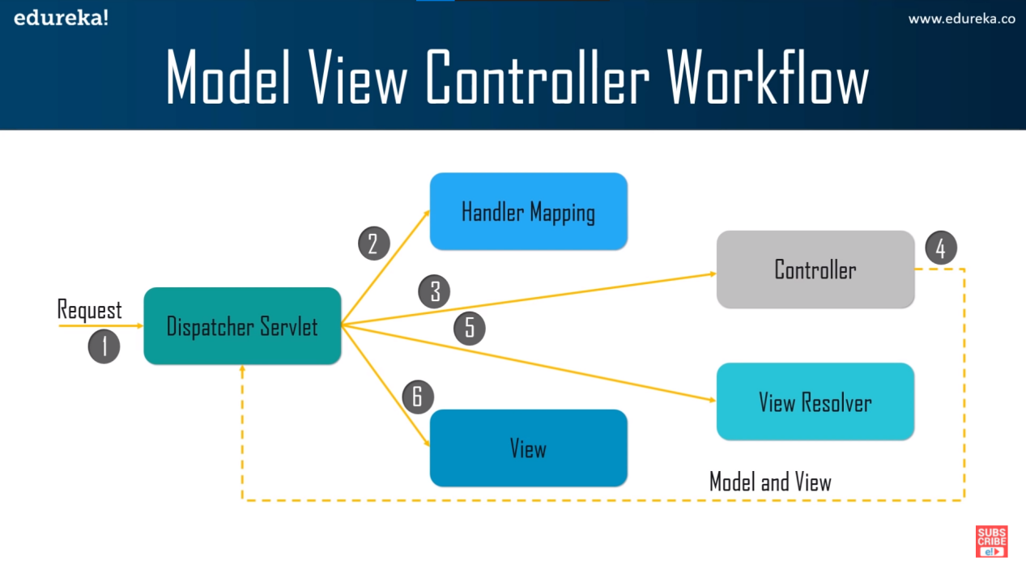

1. Dependency Injection

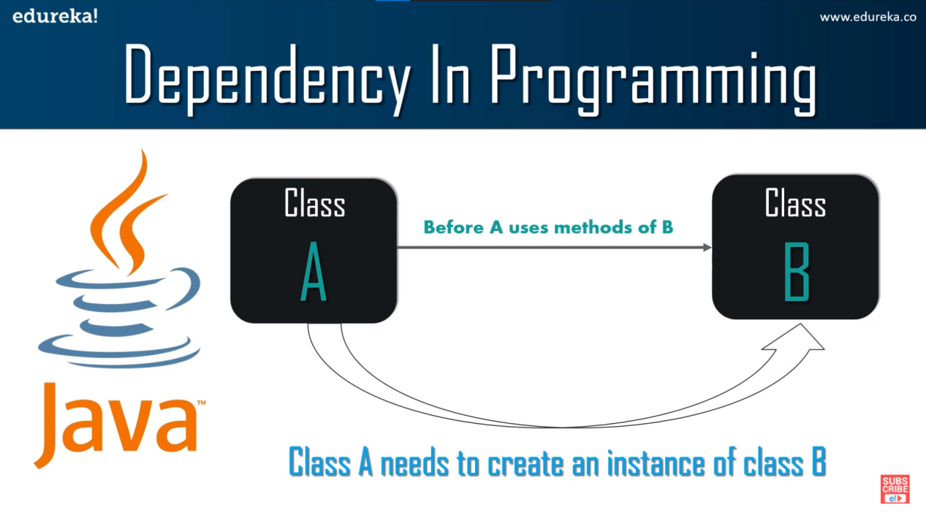

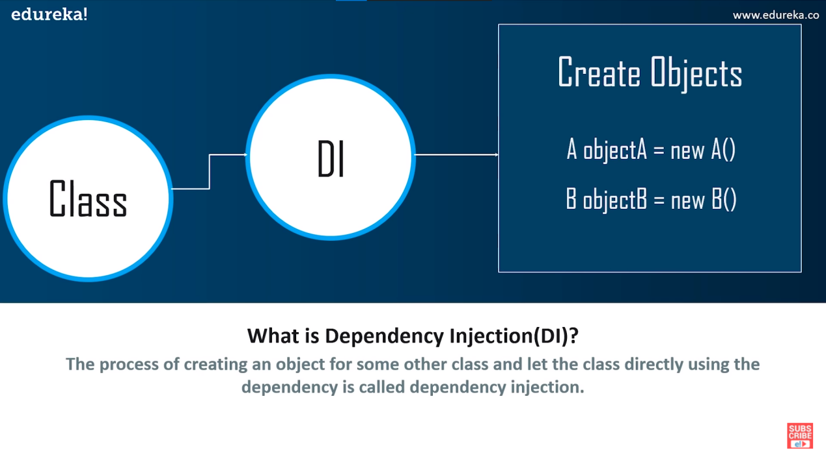

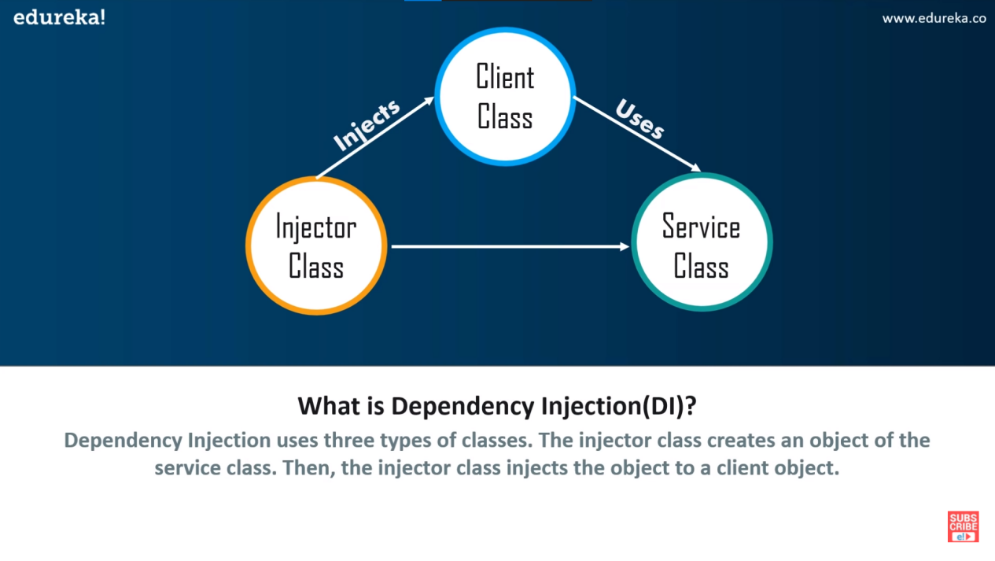

17 IoC Inversion of Control

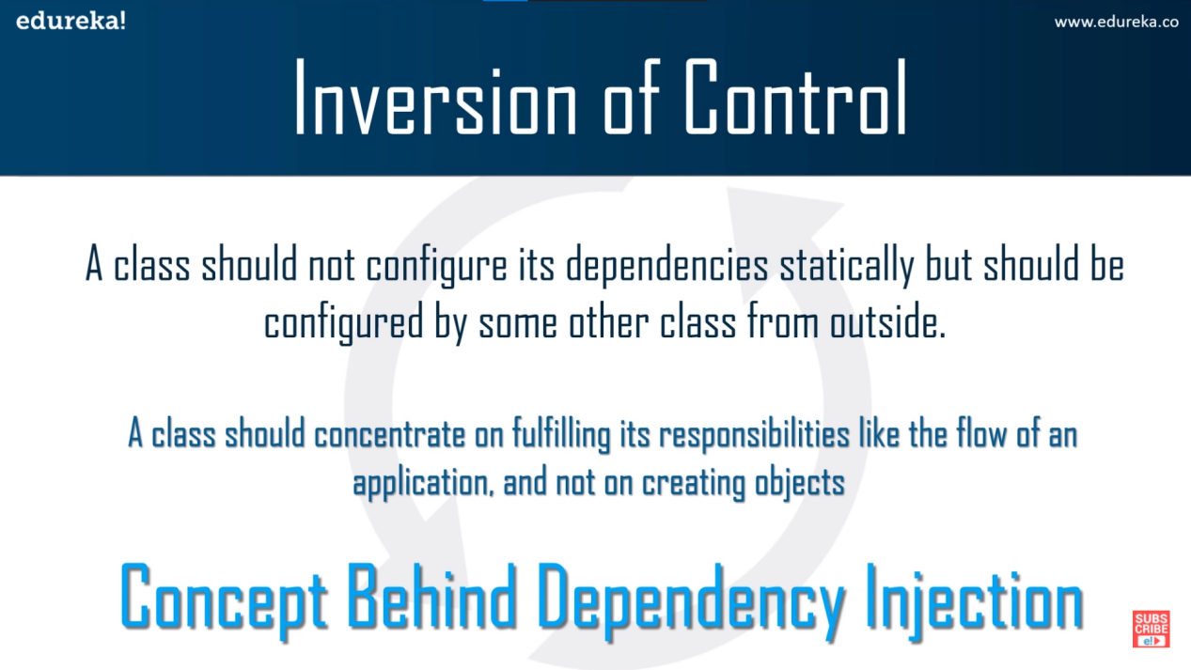

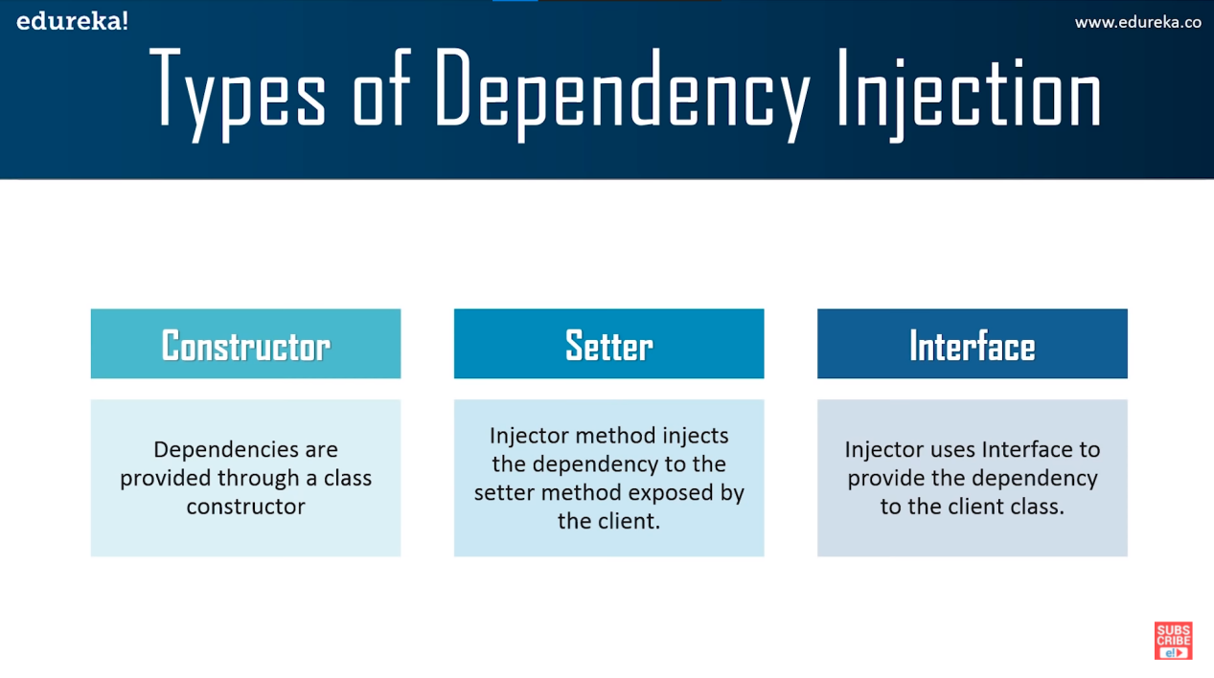

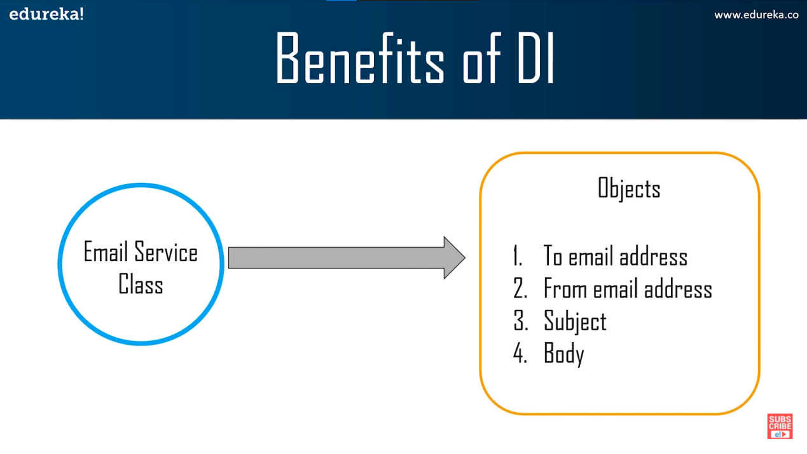

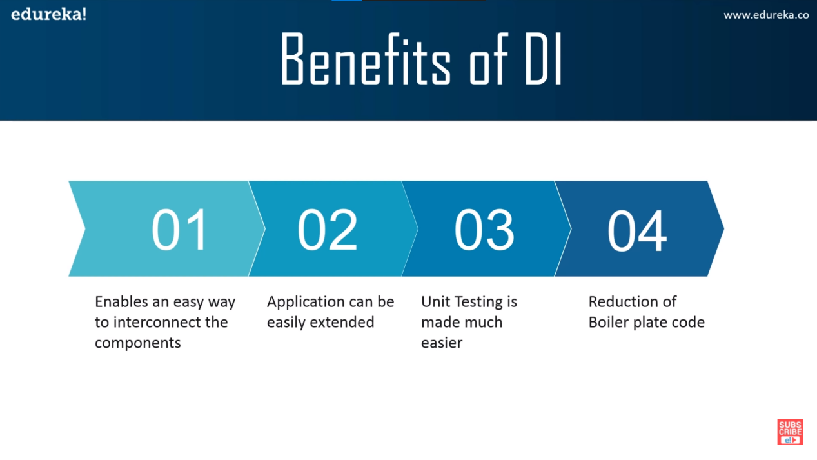

1. REST API :

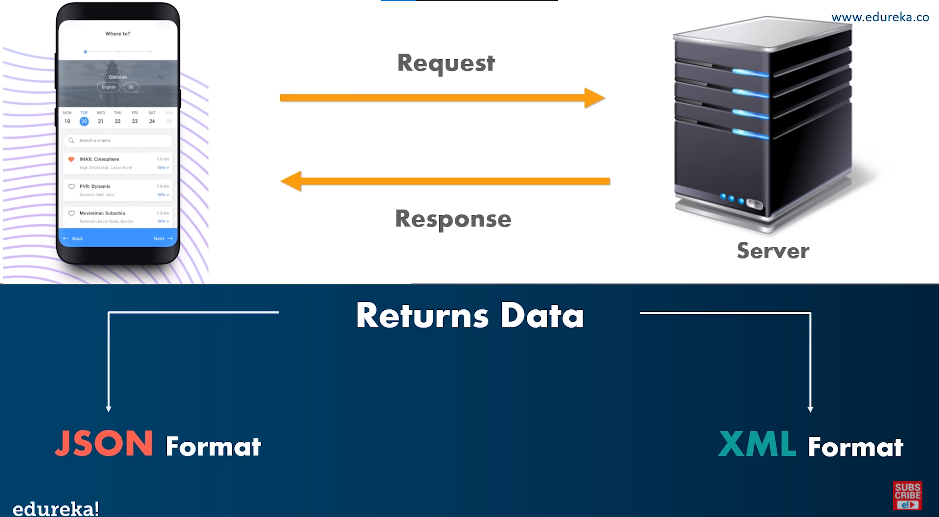

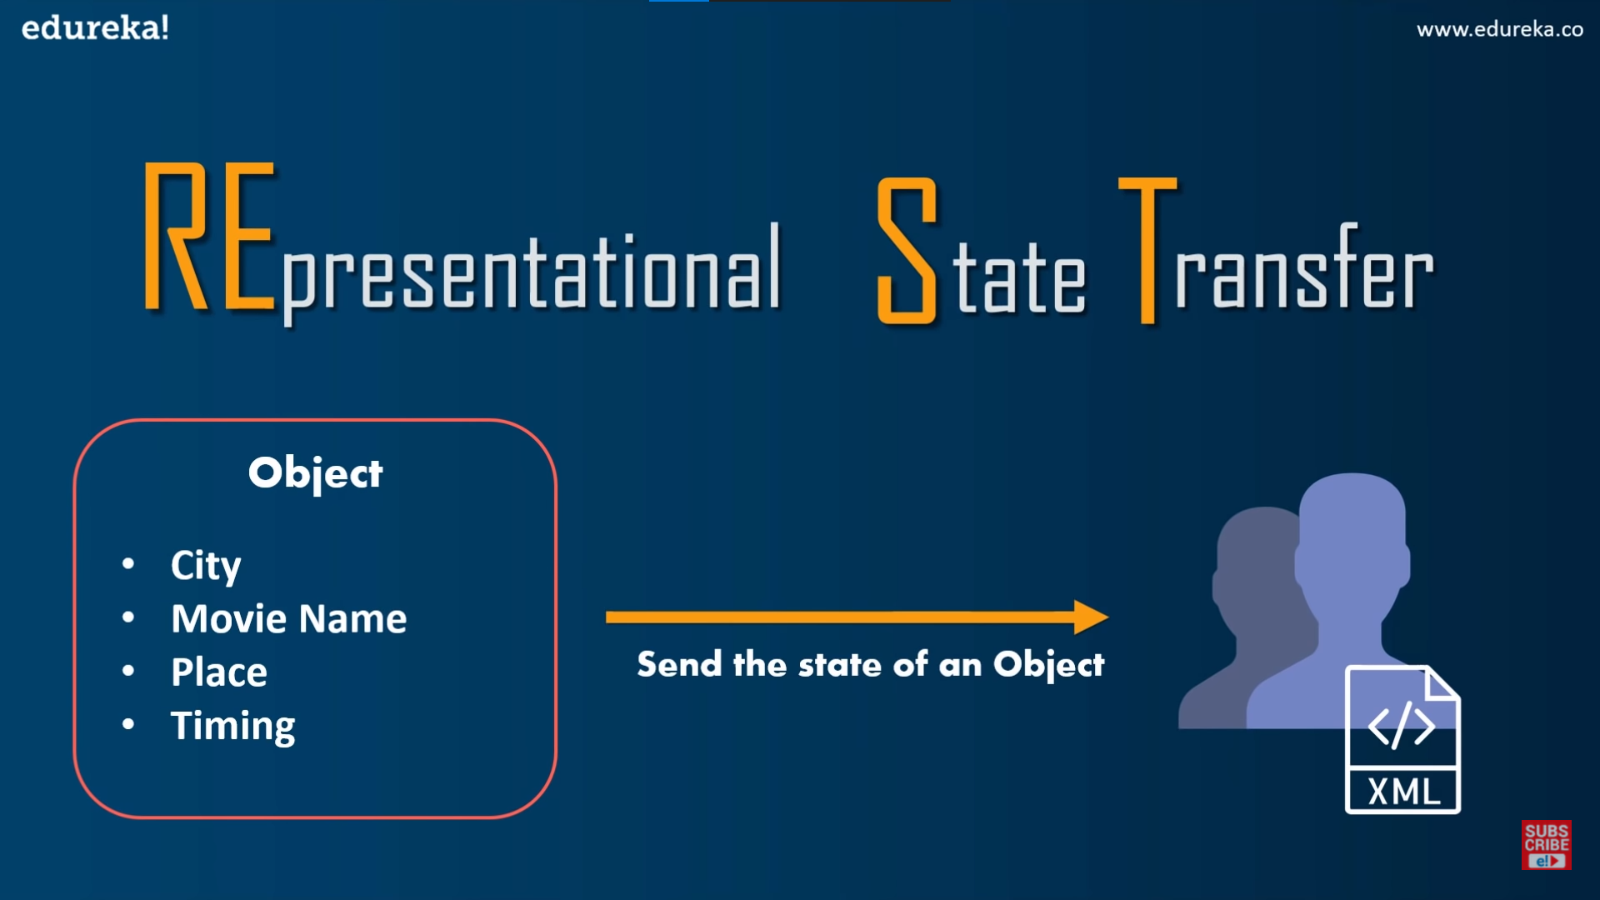

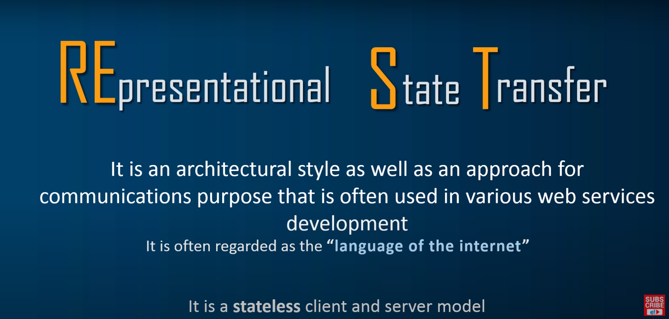

18 . Features of REST API

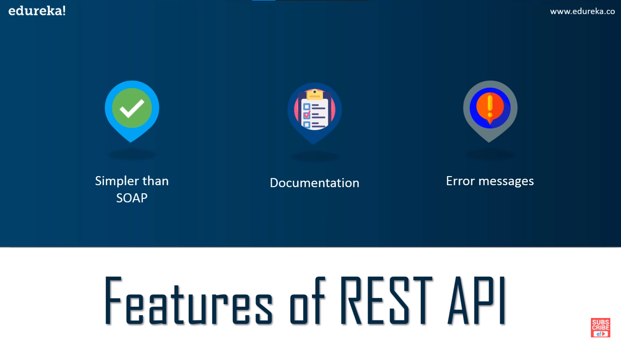

20 . Principles of REST API

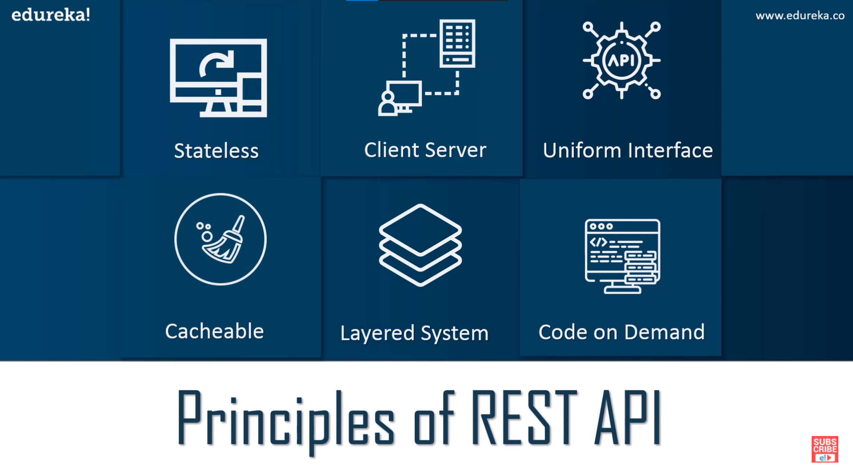

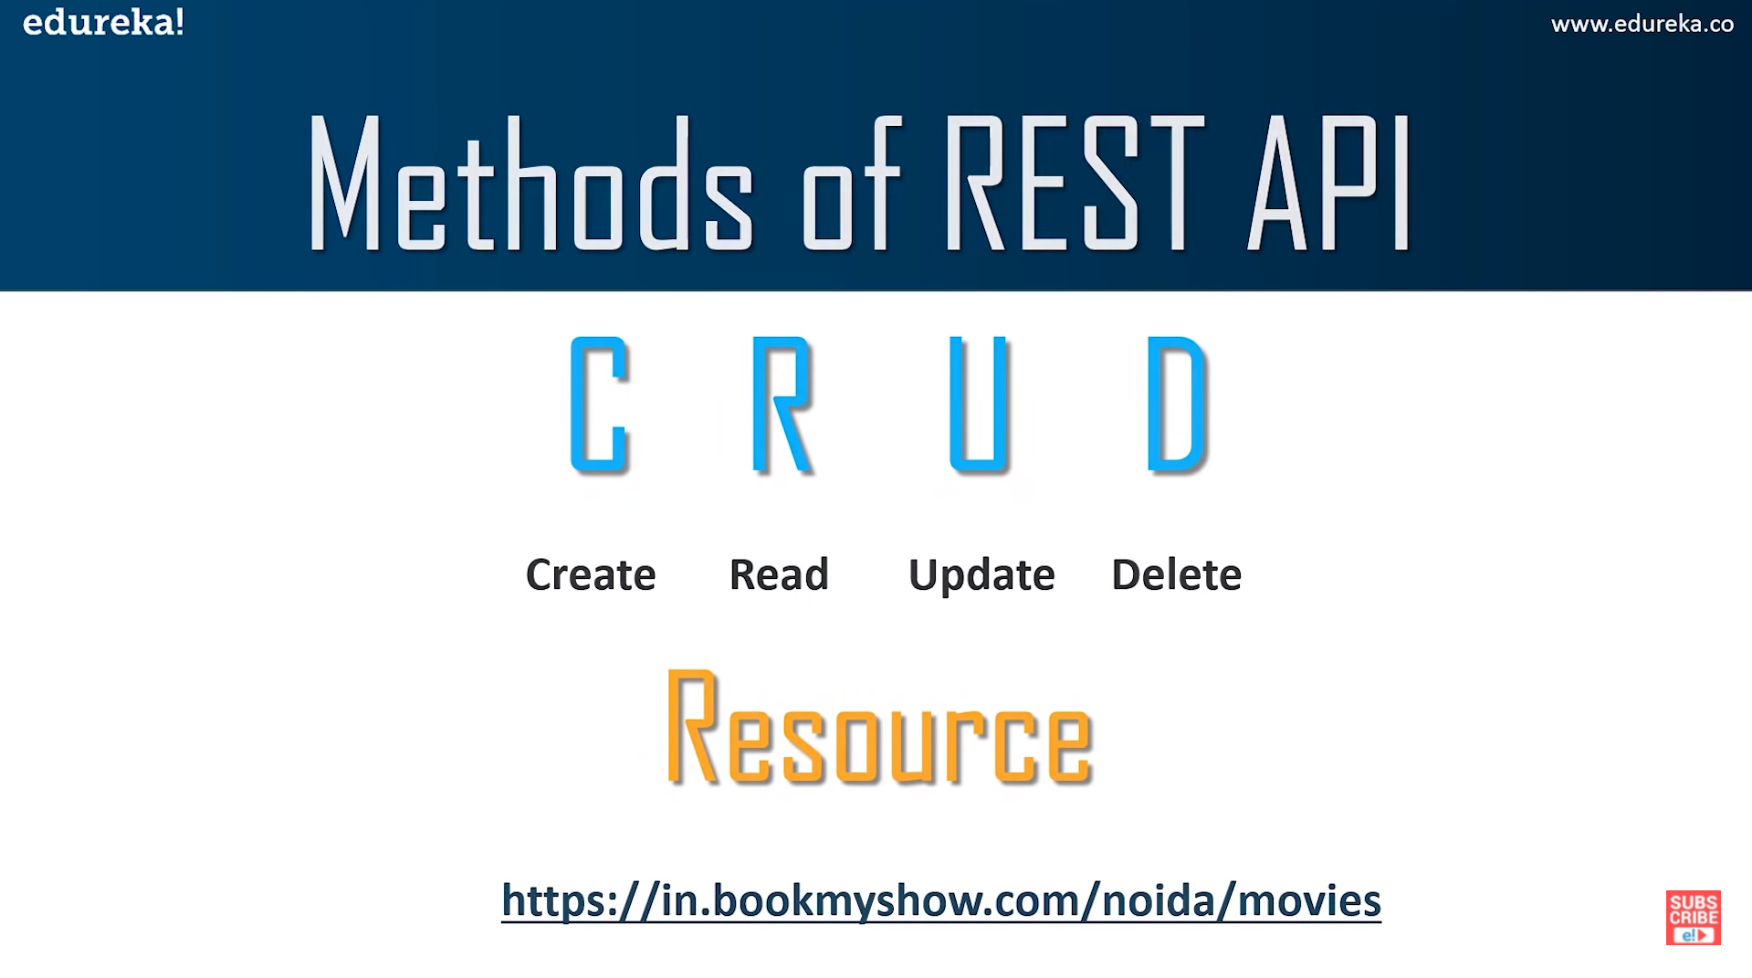

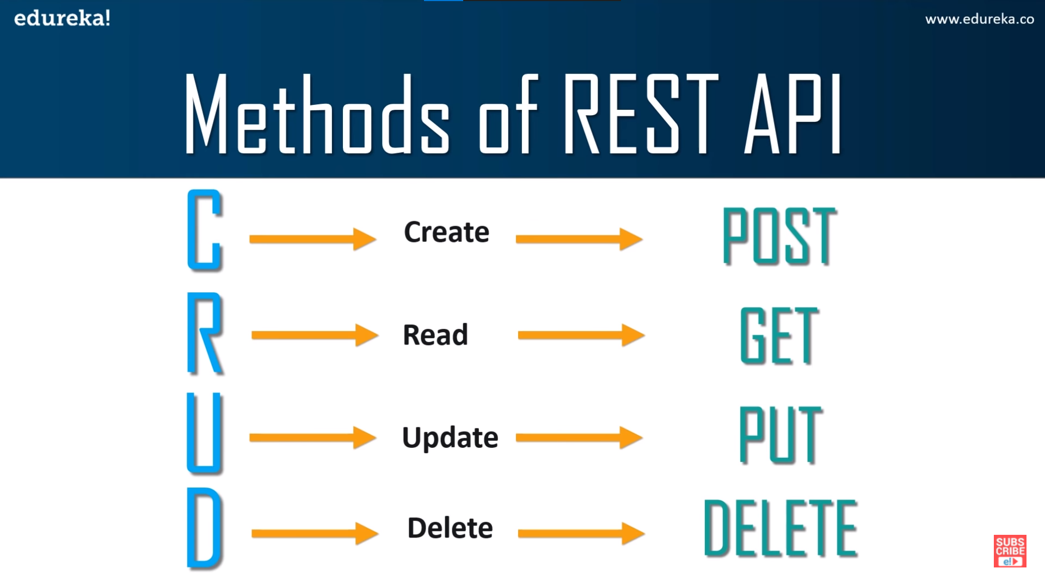

21 Spring Data REST :

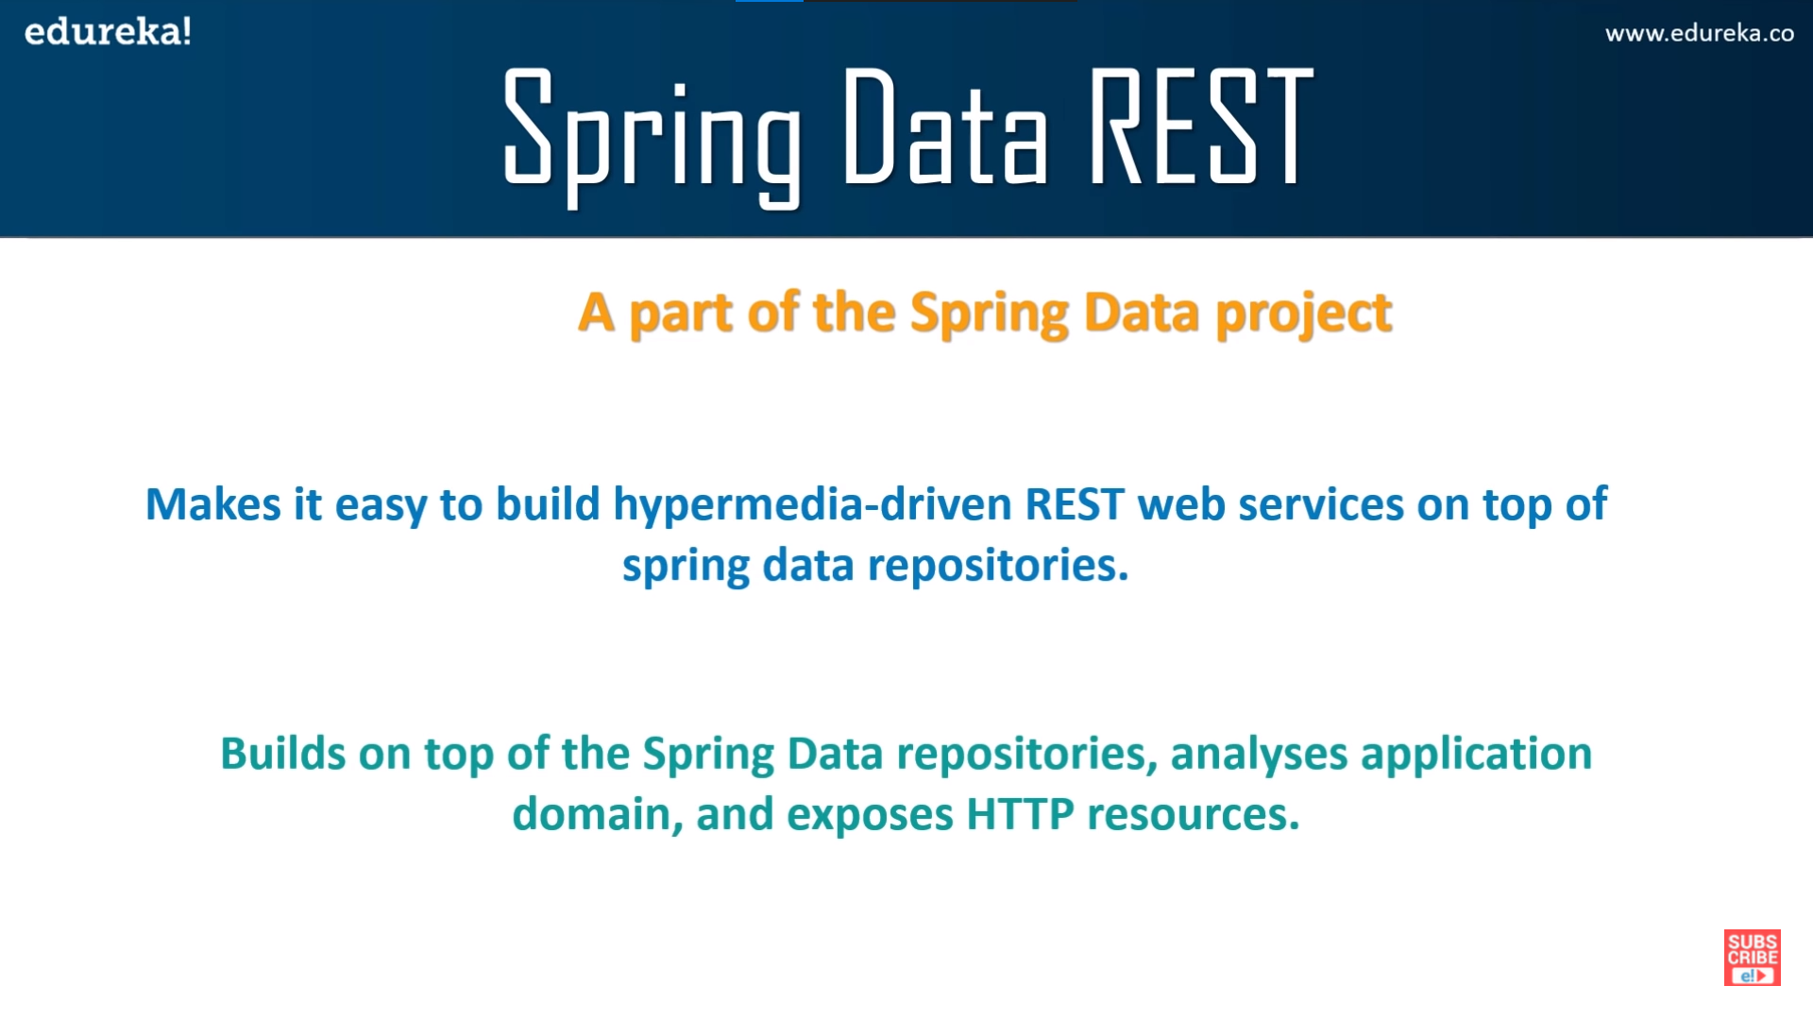

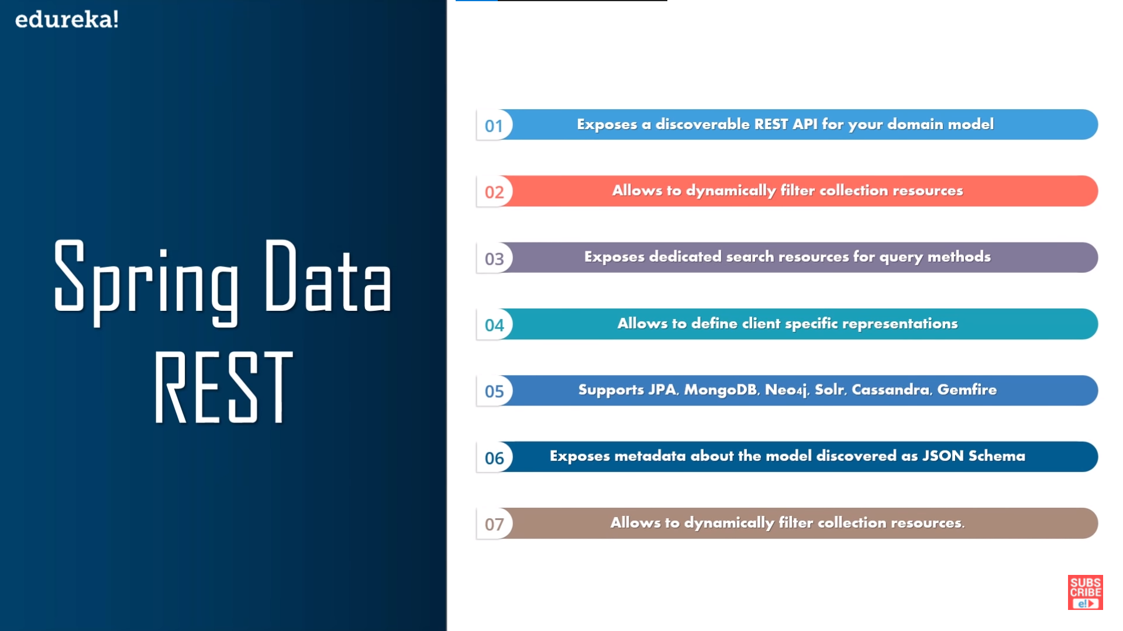

21 . Spring Security :

